**Bell, Vanessa (1879-1961)**

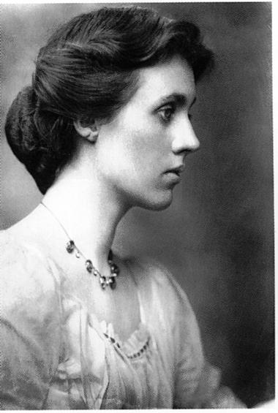SUMMARY

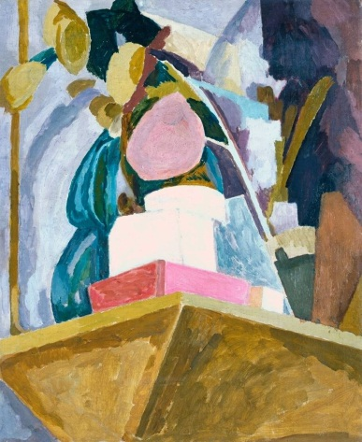Vanessa Bell was a painter and decorative artist, an innovator in interior design and a member of the Bloomsbury Group. She was a key figure in the ground-breaking Omega Workshops, set up by Roger Fry in 1913. Sister of the novelist Virginia Woolf, she also designed dustjackets for Woolf’s publications with the Hogarth Press. Her most celebrated paintings, inspired in part by the European post-impressionist paintings of the period, are characterised by strong geometrical elements, bold use of colour, and emphatic outlines, while her subjects are often intimate and domestic.

Bell’s *Still Life on Corner of a Mantelpiece* (1914), a painting displaying clear cubist influences.

url: <http://www.tate.org.uk/art/artworks/bell-still-life-on-corner-of-a-mantelpiece-t01133>

**Vanessa Bell as a young woman**

url: <http://sexualityinart.wordpress.com/2007/08/18/sisters-virginia-woolf-vanessa-bell-pens-brushes-presses-and-minds-of-their-own/>

MAIN ENTRY

The eldest daughter of the literary critic and author Sir Leslie Stephen and Julia Prinsep Stephen, Vanessa Bell was permitted to pursue her studies in painting from a relatively young age, attending art schools in her late teens and early twenties. Following her father’s death in 1904, she sold the family home and set up a household with her sister Virginia and their two brothers. Their Gordon Square home was quickly established as a meeting-place for what was to become known as the Bloomsbury Group of artists, writers and political thinkers active in the early decades of the twentieth century. Vanessa married one of this group, the art critic Clive Bell, in 1907.

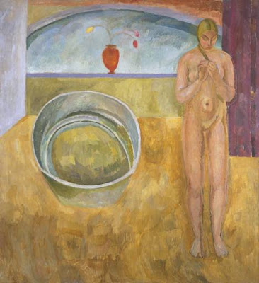Four paintings by Bell appeared in the British, French and Russian Artists exhibition of 1912-13, held by the art critic Roger Fry (with whom Bell had an affair from 1911 to 1913) as a follow-up to his highly controversial POST-IMPRESSIONIST exhibition of 1910. Here Bell was exhibited alongside artists such as Pablo Picasso, Henri Matisse and Paul Cézanne, as well as Duncan Grant with whom Bell was to establish a long-term relationship from 1913 onwards. The post-impressionist movement had a significant influence on Bell’s work and encouraged her to be freer with form and more exuberant in her use of colour. Her first solo exhibition was at the Independent Gallery in London in 1922, and she had four further solo shows in London galleries. In the post-war years Bell, in common with many artists of her generation, returned to a more representational style of painting.

Bell’s *The Tub* (1917). This large painting remained undisplayed until it was rediscovered during the revival of interest in the Bloomsbury group in the 1970s.

url: <http://www.tate.org.uk/art/artworks/bell-the-tub-t02010>

Bell was a central figure in the ground-breaking Omega Workshops, founded by Fry in Fitzroy Square, London, in 1913. The ethos of the Omega was to design and produce beautiful, hand-made home furnishings such as textiles, furniture and lampshades, on a collective basis – none of the works were signed by an individual. While the Studios only survived for six years, being unable to sustain itself commercially, the Omega aesthetic regained some popularity and influence from the late twentieth century onwards. Often in collaboration with Grant, Bell continued to produce designs for, and often produce, murals, ceramics, textiles, carpets, curtains, lighting and furniture, for decades after the closure of Omega.

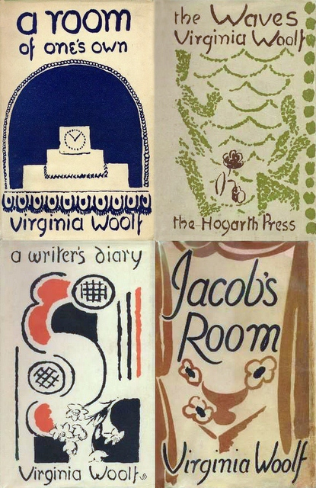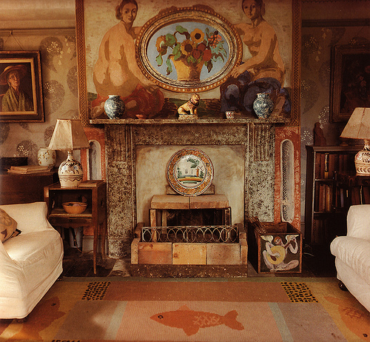Bell spent most of her adult life at Charleston Farmhouse, near Firle in East Sussex, where she moved with Grant in 1916, though they also kept a room for Clive Bell. Grant’s lover David Garnett and the economist John Maynard Keynes also lived at Charleston for long periods. Over time she and Grant decorated and re-decorated every room, and much of the furniture. She and Grant designed and painted the murals for Berwick Church near Charleston in 1941 and 1942. Bell was also an illustrator, producing woodcut prints to illustrate Virginia Woolf’s short story *Kew Gardens* and a later editions of the short story collection *Monday or Tuesday*,as well as designing the dustjackets for many other Hogarth Press publications including all but two of those by Woolf.

The drawing room at Charleston, featuring Bell and Grant’s own interior decorations and designs. A self-portrait of Bell, dating around 1958, hangs to the left of the fireplace.

url: <http://www.decorartsnow.com/2012/01/12/now-and-then-inspired-by-the-bloomsbury-group/>

**Further Reading**

Anscombe, Isabelle (1981) *Omega and After: Bloomsbury and the Decorative Arts,* London: Thames and Hudson.

Shone, Richard (1976) *Bloomsbury Portraits: Vanessa Bell, Duncan Grant, and Their Circle*, Oxford: Phaidon.

Spalding, Frances (1983) *Vanessa Bell,* New York: Ticknor & Fields.

Tranter, Rachel (1998) *Vanessa Bell: A Life of Painting*, London: Cecil Woolf.

A selection of the dustjackets Bell designed for her sister Virginia Woolf’s publications.

url: <http://londonandcompany.blogspot.co.uk/2010_07_01_archive.html> - I’ve used this composite of four dustjackets but the copyright for this image may be complicated and lie with the owner of this site; there are numerous other examples of Bell designed images online which could be used as an alternative, if copyright is difficult. Any Woolf dustjacket would be fine – the annotation would just have to be amended to ‘A dustjacket designed by Bell for her sister Virginia Woolf’s *XXX*.’

Bryony Randall, University of Glasgow